**Cloud Computing:**

* Cloud is aterm used to **describe a global network of servers**, each with a unique function
* Cloud Computing is the **delivery of computing services** such as servers, storage, databases, networking, software, analytics, intelligence, and more, over the Cloud (Internet).
* Cloud Computing provides an **alternative to the on-premises datacentre.** With an on-premises datacentre, we have to manage everything, such as purchasing and installing hardware, virtualization, installing the operating system, and any other required applications, setting up the network, configuring the firewall, and setting up storage for data. After doing all the set-up, we become responsible for maintaining it through its entire lifecycle.
* But if we choose Cloud Computing, a **cloud vendor is responsible for the hardware purchase and maintenance**. They also provide a wide variety of software and platform as a service. We can take any required services on rent. The **cloud computing services will be charged based on usage**.
* The cloud environment **provides an easily accessible online portal** that makes handy for the user to manage the compute, storage, network, and application resources. Some cloud service providers are in the following figure.

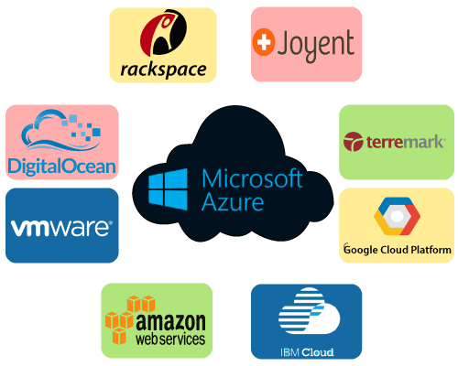

**Advantages of cloud computing:**

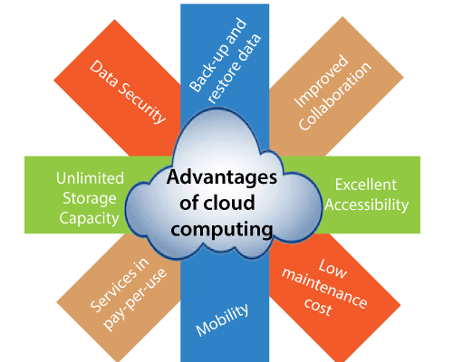

### 1)Back-up and restore data

Once the data is stored in the cloud, it is easier to get back-up and restore that data using the cloud.

### 2)Improved collaboration

Cloud applications improve collaboration by allowing groups of people to quickly and easily share information in the cloud via shared storage.

### 3) Excellent accessibility

Cloud allows us to quickly and easily access store information anywhere, anytime in the whole world, using an internet connection. An internet cloud infrastructure increases organization productivity and efficiency by ensuring that our data is always accessible.

### 4) Low maintenance cost

Cloud computing reduces both hardware and software maintenance costs for organizations.

### 5) Mobility

Cloud computing allows us to easily access all cloud data via mobile.

### 6) Services in the pay-per-use model

Cloud computing offers Application Programming Interfaces (APIs) to the users for access services on the cloud and pays the charges as per the usage of service.

### 7) Unlimited storage capacity

Cloud offers us a huge amount of storing capacity for storing our important data such as documents, images, audio, video, etc. in one place.

### 8) Data security

Data security is one of the biggest advantages of cloud computing. Cloud offers many advanced features related to security and ensures that data is securely stored and handled.

## Disadvantages of Cloud Computing

A list of the disadvantage of cloud computing is given below -

### 1) Internet Connectivity

As you know, in cloud computing, every data (image, audio, video, etc.) is stored on the cloud, and we access these data through the cloud by using the internet connection. If you do not have good internet connectivity, you cannot access these data. However, we have no any other way to access data from the cloud.

### 2) Vendor lock-in

Vendor lock-in is the biggest disadvantage of cloud computing. Organizations may face problems when transferring their services from one vendor to another. As different vendors provide different platforms, that can cause difficulty moving from one cloud to another.

### 3) Limited Control

As we know, cloud infrastructure is completely owned, managed, and monitored by the service provider, so the cloud users have less control over the function and execution of services within a cloud infrastructure.

### 4) Security

Although cloud service providers implement the best security standards to store important information. But, before adopting cloud technology, you should be aware that you will be sending all your organization's sensitive information to a third party, i.e., a cloud computing service provider. While sending the data on the cloud, there may be a chance that your organization's information is hacked by Hackers.

## Types of Cloud Computing

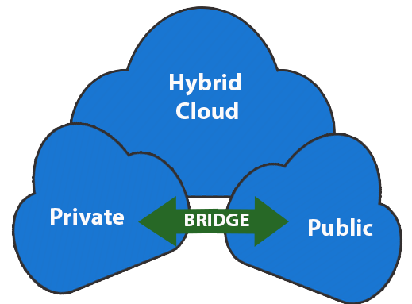

* **Public Cloud:** Cloud Computing infrastructure is shared with the public by service providers over the internet. It supports multiple customers i.e, enterprises. **Vendor lock-ins and escalating cloud application costs** are common challenges with the public cloud. Apart from these issues, enterprises also have to ensure that all applications are not concentrated on a single public cloud environment, exposing the applications to security vulnerabilities
* **Private Cloud:** Cloud Computing infrastructure is shared **with private organizations by service providers** over the internet. It supports one enterprise.
* **Hybrid Cloud:** It is the combination of public and private clouds, which is bounded together by technology that allows data applications to be shared between them.

**Differences between Public Cloud and Private Cloud is as follows:**

| **Public Cloud** | **Private Cloud** |
| --- | --- |
| Cloud Computing infrastructure is shared with the public by service providers over the internet. It supports multiple customers i.e, enterprises. | Cloud Computing infrastructure is shared with private organizations by service providers over the internet. It supports one enterprise. |
| Multi-Tenancy i.e, Data of many enterprises are stored in a shared environment but are isolated. Data is shared as per rule, permission, and security. | Single Tenancy i.e, Data of a single enterprise is stored. |
| Cloud service provider provides all the possible services and hardware as the user-base is the world. Different people and organizations may need different services and hardware. Services provided must be versatile. | Specific services and hardware as per the need of the enterprise are available in a private cloud. |
| It is hosted at the Service Provider site. | It is hosted at the Service Provider site or enterprise. |
| organizationsenterprisesIt is connected to the public internet. | It only supports connectivity over the private network. |
| Scalability is very high, and reliability is moderate. | Scalability is limited, and reliability is very high. |
| Cloud service provider manages the cloud and customers use them. | Managed and used by a single enterprise. |
| It is cheaper than the private cloud. | It is costlier than the public cloud. |
| Security matters and dependent on the service provider. | It gives a high class of security. |
| Performance is low to medium. | Performance is high. |
| It has shared servers. | It has dedicated servers. |
| Example: Amazon web service (AWS) and Google AppEngine etc. | Example: Microsoft KVM, HP, Red Hat & VMWare etc. |

## Types of Cloud Services:

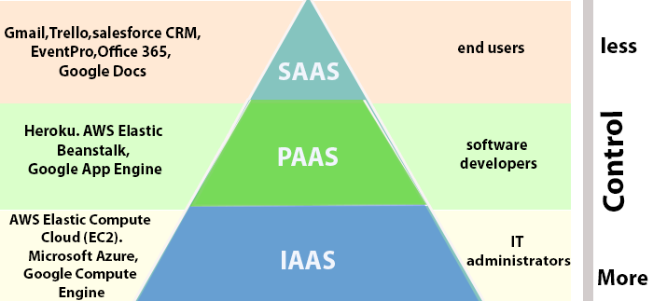

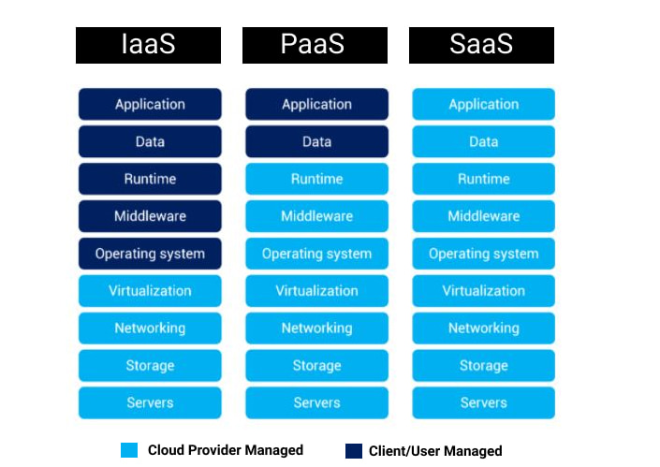

1. **Infrastructure as a Service (IaaS): In IaaS, we can rent IT infrastructures like servers and virtual machines (VMs), storage, networks, operating systems from a cloud service vendor.**

* Using IaaS, we don’t need to care about the hardware or virtualization software, but other than that, we do have to manage everything else. Using IaaS, we get maximum flexibility, but still, we need to put more effort into maintenance.
* Amazon Web Service (AWS) is the first IaaS provider. Some other related IaaS services are Google Cloud Platform, Alibaba Cloud, IBM Cloud, Microsoft Azure, SalesForces, and Cisco MetaCloud.

1. **Platform as a Service (PaaS):** **This service provides an on-demand environment for developing, testing, delivering, and managing software applications.** The developer is responsible for the application, and the PaaS vendor provides the ability to deploy and run it. Using PaaS, the flexibility gets reduce, but the management of the environment is taken care of by the cloud vendors.

**Examples:** Amazon Web Services and Rackspace.

1. **Software as a Service (SaaS):** **It provides a centrally hosted and managed software services to the end-users.** It delivers software over the internet, on-demand, and typically on a subscription basis. E.g., Microsoft One Drive, Dropbox, WordPress, Office 365, and Amazon Kindle. SaaS is used to minimize the operational cost to the maximum extent. Saas provides clients with ability to use software applications over the internet via subscription basis. Clients can access applications from anywhere via web.

Advantages of Saas include the following:

* **Accessibility:** Ability to run via an internet browser 24/7 from any device
* **Operational Management:** No installation, equipment updates or traditional licensing management
* **Cost Effective:** No upfront hardware costs and flexible payment methods such as pay-as-you-go models
* **Scalability:** Easily scale a solution to accommodate changing needs
* **Data Storage:** Data is routinely saved in the cloud
* **Analytics:** Access to data reporting and intelligence tools
* **Increase Security:** SaaS providers invest heavily in security technology and expertise

**Examples:** Google Workspace, Dropbox, Salesforce, Cisco WebEx, Concur,

GoToMeeting.

**Evolution of cloud computing:**

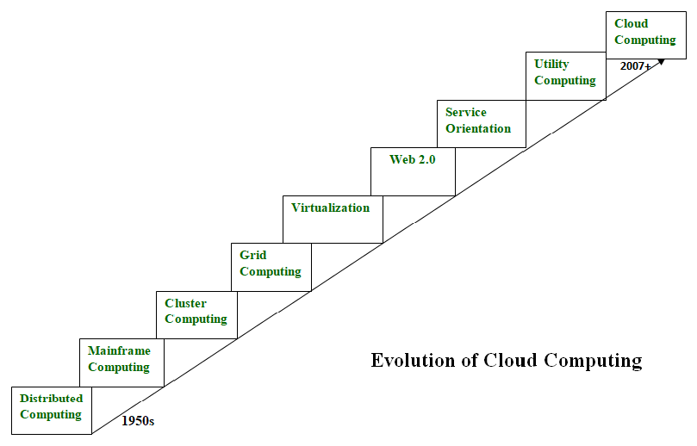

* **Distributed Systems:**  
  It is a composition of multiple independent systems but all of them are depicted as a single entity to the users. The purpose of distributed systems is to share resources and also use them effectively and efficiently. Distributed systems possess characteristics such as scalability, concurrency, continuous availability, heterogeneity, and independence in failures. But the main problem with this system was that all the systems were required to be present at the same geographical location. Thus to solve this problem, distributed computing led to three more types of computing and they were-Mainframe computing, cluster computing, and grid computing.
* **Mainframe computing:**  
  Mainframes which first came into existence in 1951 are highly powerful and reliable computing machines. These are responsible for handling large data such as massive input-output operations. Even today these are used for bulk processing tasks such as online transactions etc. These systems have almost no downtime with high fault tolerance. After distributed computing, these increased the processing capabilities of the system. But these were very expensive. To reduce this cost, cluster computing came as an alternative to mainframe technology.
* **Cluster computing:**  
  In 1980s, cluster computing came as an alternative to mainframe computing. Each machine in the cluster was connected to each other by a network with high bandwidth. These were way cheaper than those mainframe systems. These were equally capable of high computations. Also, new nodes could easily be added to the cluster if it was required. Thus, the problem of the cost was solved to some extent but the problem related to geographical restrictions still pertained. To solve this, the concept of grid computing was introduced.
* **Grid computing:**

In 1990s, the concept of grid computing was introduced. It means that different systems were placed at entirely different geographical locations and these all were connected via the internet. These systems belonged to different organizations and thus the grid consisted of heterogeneous nodes. Although it solved some problems but new problems emerged as the distance between the nodes increased. The main problem which was encountered was the low availability of high bandwidth connectivity and with it other network associated issues. Thus. cloud computing is often referred to as “Successor of grid computing”.

* **Virtualization:**  
  It was introduced nearly 40 years back. It refers to the process of creating a virtual layer over the hardware which allows the user to run multiple instances simultaneously on the hardware. It is a key technology used in cloud computing. It is the base on which major cloud computing services such as Amazon EC2, VMware vCloud, etc work on. Hardware virtualization is still one of the most common types of virtualization.
* **Web 2.0:**

It is the interface through which the cloud computing services interact with the clients. It is because of Web 2.0 that we have interactive and dynamic web pages. It also increases flexibility among web pages. Popular examples of web 2.0 include Google Maps, Facebook, Twitter, etc. Needless to say, social media is possible because of this technology only. In gained major popularity in 2004.

* **Service orientation:**  
  It acts as a reference model for cloud computing. It supports low-cost, flexible, and evolvable applications. Two important concepts were introduced in this computing model. These were Quality of Service (QoS) which also includes the SLA (Service Level Agreement) and Software as a Service (SaaS).
* **Utility computing:**  
  It is a computing model that defines service provisioning techniques for services such as compute services along with other major services such as storage, infrastructure, etc which are provisioned on a pay-per-use basis.

# Underlying Principles of Parallel and Distributed Computing System

* The terms parallel computing and distributed computing are used interchangeably.

**Parallel Processing:**

* Processing of multiple tasks simultaneously on multiple processors is called **parallel processing**.
* The parallel program consists of multiple active processes ( tasks) simultaneously solving a given problem.
* A given task is divided into multiple subtasks using a divide-and-conquer technique, and each subtask is processed on a different central processing unit (CPU).

[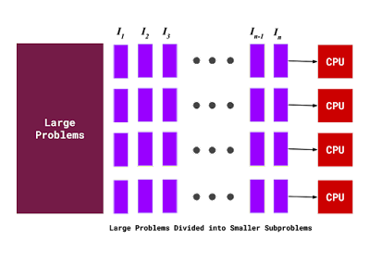](https://1.bp.blogspot.com/-ggVLAQUyP8c/X3hAdcNQQXI/AAAAAAAAAxo/-_WXsDuQ4nkyttpgeRBcSHsz_GQ1UlfUQCLcBGAsYHQ/s960/parallel+processing.png)

* Many applications today require more computing power than a traditional sequential computer can offer.
* Parallel Processing provides a cost-effective solution to this problem by increasing the number of CPUs in a computer and by adding an efficient communication system between them.
* The workload can then be shared between different processors. This setup results in higher computing power and performance than a single processor a system offers.

### Applications for Parallel Processing

* Science and Engineering
  + Atmospheric Analysis
  + Earth Sciences
  + Electrical Circuit Design
* Industrial and Commercial
  + Data Mining
  + Web Search Engine
  + Graphics Processing

### Why to use parallel processing

* **Save time and money:** More resources at a task will shorten its time for completion, with potential cost savings.
* **Provide concurrency:** Single computing resources can only do one task at a time.
* **Serial computing limits:** Transmission speeds depend directly upon hardware.

**Distributed computer:**

* A distributed computer system consists of multiple software components that are on multiple computers, but run as a single system. The computers that are in a distributed system can be physically close together and connected by a local network, or they can be geographically distant and connected by a wide area network.
* A distributed system can consist of any number of possible configurations, such as mainframes, personal computers, workstations, minicomputers, and so on. The goal of distributed computing is to make such a network work as a single computer.

Distributed systems offer many benefits over centralized systems, including the following:

* Scalability: The system can easily be expanded by adding more machines as needed.
* Redundancy: Several machines can provide the same services, so if one is unavailable, work does not stop. Additionally, because many smaller machines can be used, this redundancy does not need to be prohibitively expensive.

Examples of distributed systems and applications of distributed computing include the following:

* telecommunication networks:
  + telephone networks and cellular networks
  + computer networks such as the Internet
* network applications:
* World Wide Web and peer-to-peer networks
* massively multiplayer online games and virtual reality communities,
* real-time process control:
* aircraft control systems,
* industrial control systems

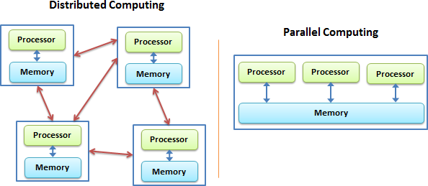

While both distributed computing and parallel systems are widely available these days, the main difference between these two is that a parallel computing system consists of multiple processors that communicate with each other using a shared memory, whereas a distributed computing system contains multiple processors connected by a communication network.

|  |  |  |
| --- | --- | --- |
| **S.NO** | **Parallel Computing** | **Distributed Computing** |
| 1. | Many operations are performed simultaneously | System components are located at different locations |
| 2. | Single computer is required | Uses multiple computers |
| 3. | Multiple processors perform multiple operations | Multiple computers perform multiple operations |
| 4. | It may have shared or distributed memory | It have only distributed memory |
| 5. | Processors communicate with each other through bus | Computer communicate with each other through message passing. |
| 6. | Improves the system performance | Improves system scalability, fault tolerance and resource sharing capabilities |

# Characteristics of Cloud Computing:

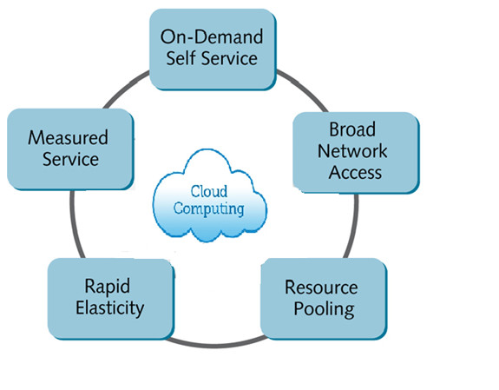

There are basically 5 essential characteristics of cloud computing:

1. **On-demand self-services:**

The Cloud computing services does not require any human administrators, user themselves are able to provision, monitor and manage computing resources as needed.

1. **Broad network access:**

The Computing services are generally provided over standard networks and heterogeneous devices.

1. **Rapid elasticity:**

The cloud computing capabilities can be released elastically. It enables you to scale the cloud computing services inward and outward, and it helps to be commensurate with the dynamic demand posted by the end-users.

1. **Resource pooling:**

* The IT resource (e.g., networks, servers, storage, applications, and services) present are shared across multiple applications and occupant in an uncommitted manner. Multiple clients are provided service from a same physical resource.
* Cloud computing delivers affordable resource pooling solutions. With resource pooling, organizations can reduce substantial computing costs, and it helps in the dynamic pooling of resources that enable them to deliver computing services to several consumers.

1. **Measured service:**

The resource utilization is tracked for each application and occupant, it will provide both the user and the resource provider with an account of what has been used. This is done for various reasons like monitoring billing and effective use of resource.

**Elasticity in cloud:**

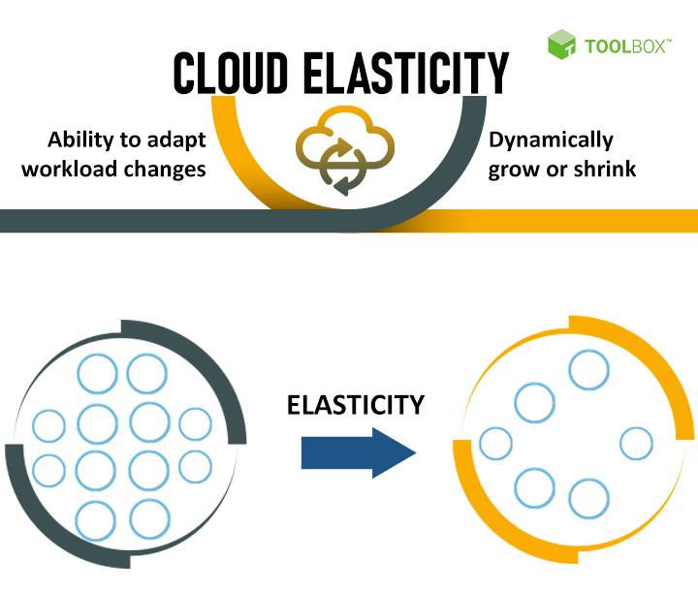

* Сloud elasticity is a system's ability to manage available resources according to the current workload requirements dynamically.
* The Elasticity refers to the ability of a cloud to automatically expand or compress the infrastructural resources on a sudden-up and down in the requirement so that the workload can be managed efficiently. This elasticity helps to minimize infrastructural cost.
* This is **not applicable for all kind of environment**, it is helpful to address only those scenarios where the resources requirements fluctuate up and down suddenly for a specific time interval. It is not quite practical to use where persistent resource infrastructure is required to handle the heavy workload.
* It is most commonly used in pay-per-use, public cloud services. Where IT managers are willing to pay only for the duration to which they consumed the resources.

**Example:**

Consider an online shopping site whose transaction workload increases during festive season like Christmas. So for this specific period of time, the resources need a spike up. In order to handle this kind of situation, we can go for Cloud-Elasticity service rather than Cloud Scalability. As soon as the season goes out, the deployed resources can then be requested for withdrawal.

**Difference Between Cloud Elasticity and Scalability :**

|  | **Cloud Elasticity** | **Cloud Scalability** |
| --- | --- | --- |
| **1** | Elasticity is used just to meet the sudden up and down in the workload for a small period of time. | Scalability is used to meet the static increase in the workload. |
| **2** | Elasticity is used to meet dynamic changes, where the resources need can increase or decrease. | Scalability is always used to address the increase in workload in an organization. |
| **3** | Elasticity is commonly used by small companies whose workload and demand increases only for a specific period of time. | Scalability is used by giant companies whose customer circle persistently grows in order to do the operations efficiently. |
| **4** | It is a short term planning and adopted just to deal with an unexpected increase in demand or seasonal demands. | Scalability is a long term planning and adopted just to deal with an expected increase in demand. |

**On‐demand Provisioning:**

Cloud provisioning means allocating a cloud service provider’s resources to a customer. It is a key feature of cloud computing. It refers to how a client gets cloud services and resources from a provider. The cloud services that customers can subscribe to include infrastructure-as-a-service (IaaS), software-as-a-service (SaaS), and platform-as-a-service (PaaS) in public or private environments. In The

On-demand computing is a delivery model in which computing resources are made available to the user as needed. The resources may be maintained within the user’s enterprise, or made available by a cloud service provider. When the services are provided by a third party, the term cloud computing is used as a synonym for on –demand computing.

Effectively using of cloud computing:

* Over-provisioning: purchased resources are not fully utilized, cost more than necessary.
* Under-provisioning: purchased resources are not sufficient to meet the actual demand, hurt application performance.

# Cloud Computing Applications

Cloud service providers provide various applications in the field of art, business, data storage and backup services, education, entertainment, management, social networking, etc.

The most widely used cloud computing applications are given below -

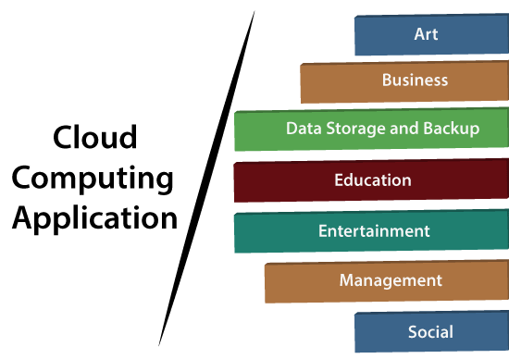

## 1. Art Applications

Cloud computing offers various art applications for quickly and easily design **attractive cards, booklets,** and **images**. Some most commonly used cloud art applications are given below:

**i) Moo**

Moo is one of the best cloud art applications. It is used for designing and printing business cards, postcards, and mini cards.

**ii. Vistaprint**

Vistaprint allows us to easily design various printed marketing products such as business cards, Postcards, Booklets, and wedding invitations cards.

**iii. Adobe Creative Cloud**

Adobe creative cloud is made for designers, artists, filmmakers, and other creative professionals. It is a suite of apps which includes PhotoShop image editing programming, Illustrator, InDesign, TypeKit, Dreamweaver, XD, and Audition.

**2. Business Applications**

Business applications are based on cloud service providers. Today, every organization requires the cloud business application to grow their business. It also ensures that business applications are 24*7 available to users.

There are the following business applications of cloud computing -

**i. MailChimp**

MailChimp is an **email publishing platform** which provides various options to **design, send,** and **save** templates for emails.

**iii. Salesforce**

Salesforce platform provides tools for sales, service, marketing, e-commerce, and more. It also provides a cloud development platform.

**iv. Chatter**

Chatter helps us to **share important information** about the organization in real time.

**v. Bitrix24**

Bitrix24 is a **collaboration** platform which provides communication, management, and social collaboration tools.

**vi. Paypal**

Paypal offers the simplest and easiest **online payment** mode using a secure internet account. Paypal accepts the payment through debit cards, credit cards, and also from Paypal account holders.

**vii. Slack**

Slack stands for **Searchable Log of all Conversation and Knowledge**. It provides a **user-friendly** interface that helps us to create public and private channels for communication.

**viii. Quickbooks**

Quickbooks works on the terminology "**Run Enterprise anytime, anywhere, on any device**." It provides online accounting solutions for the business. It allows more than 20 users to work simultaneously on the same system.

**3. Data Storage and Backup Applications**

Cloud computing allows us to store information (data, files, images, audios, and videos) on the cloud and access this information using an internet connection. As the cloud provider is responsible for providing security, so they offer various backup recovery application for retrieving the lost data.

A list of data storage and backup applications in the cloud are given below -

**i. Box.com**

Box provides an online environment for **secure content management, workflow,** and **collaboration**. It allows us to store different files such as Excel, Word, PDF, and images on the cloud. The main advantage of using box is that it provides drag & drop service for files and easily integrates with Office 365, G Suite, Salesforce, and more than 1400 tools.

**ii. Mozy**

Mozy provides powerful **online backup solutions** for our personal and business data. It schedules automatically back up for each day at a specific time.

**iii. Joukuu**

Joukuu provides the simplest way to **share** and **track cloud-based backup files**. Many users use joukuu to search files, folders, and collaborate on documents.

**iv. Google G Suite**

Google G Suite is one of the best **cloud storage** and **backup** application. It includes Google Calendar, Docs, Forms, Google+, Hangouts, as well as cloud storage and tools for managing cloud apps. The most popular app in the Google G Suite is Gmail. Gmail offers free email services to users.

## 4. Education Applications

Cloud computing in the education sector becomes very popular. It offers various **online distance learning platforms** and **student information portals** to the students. The advantage of using cloud in the field of education is that it offers strong virtual classroom environments, Ease of accessibility, secure data storage, scalability, greater reach for the students, and minimal hardware requirements for the applications.

There are the following education applications offered by the cloud -

**i. Google Apps for Education**

Google Apps for Education is the most widely used platform for free web-based email, calendar, documents, and collaborative study.

**ii. Chromebooks for Education**

Chromebook for Education is one of the most important Google's projects. It is designed for the purpose that it enhances education innovation.

**iii. Tablets with Google Play for Education**

It allows educators to quickly implement the latest technology solutions into the classroom and make it available to their students.

**iv. AWS in Education**

AWS cloud provides an education-friendly environment to universities, community colleges, and schools.

### 5. Entertainment Applications

Entertainment industries use a **multi-cloud strategy** to interact with the target audience. Cloud computing offers various entertainment applications such as online games and video conferencing.

**i. Online games**

Today, cloud gaming becomes one of the most important entertainment media. It offers various online games that run remotely from the cloud. The best cloud gaming services are Shaow, GeForce Now, Vortex, Project xCloud, and PlayStation Now.

**ii. Video Conferencing Apps**

Video conferencing apps provides a simple and instant connected experience. It allows us to communicate with our business partners, friends, and relatives using a cloud-based video conferencing. The benefits of using video conferencing are that it reduces cost, increases efficiency, and removes interoperability.

## 6. Management Applications

Cloud computing offers various cloud management tools which help admins to manage all types of cloud activities, such as resource deployment, data integration, and disaster recovery. These management tools also provide administrative control over the platforms, applications, and infrastructure.

Some important management applications are -

## i. Toggl

Toggl helps users to track allocated time period for a particular project.

## ii. Evernote

Evernote allows you to sync and save your recorded notes, typed notes, and other notes in one convenient place. It is available for both free as well as a paid version.

It uses platforms like Windows, macOS, Android, iOS, Browser, and Unix.

**7. Social Applications**

Social cloud applications allow a large number of users to connect with each other using social networking applications such as **Facebook, Twitter, Linkedln,** etc.

There are the following cloud based social applications -

**i. Facebook**

Facebook is a **social networking website** which allows active users to share files, photos, videos, status, more to their friends, relatives, and business partners using the cloud storage system. On Facebook, we will always get notifications when our friends like and comment on the posts.

**ii. Twitter**

Twitter is a **social networking** site. It is a **microblogging** system. It allows users to follow high profile celebrities, friends, relatives, and receive news. It sends and receives short posts called tweets.

**iii. Yammer**

Yammer is the **best team collaboration** tool that allows a team of employees to chat, share images, documents, and videos.

**iv. LinkedIn**

LinkedIn is a **social network** for students, freshers, and professionals.

# Architecture of Cloud Computing:

Cloud Computing, which is one of the demanding technology of the current time and which is giving a new shape to every organization by providing on demand virtualized services/resources. Starting from small to medium and medium to large, every organization use cloud computing services for storing information and accessing it from anywhere and any time only with the help of internet. In this article, we will know more about the internal architecture of cloud computing.

Transparency, scalability, security and intelligent monitoring are some of the most important constraints which every cloud infrastructure should experience. Current research on other important constraints is helping cloud computing system to come up with new features and strategies with a great capability of providing more advanced cloud solutions.

**Cloud Computing Architecture :**  
The cloud architecture is divided into 2 parts i.e.

1. Frontend
2. Backend

The below figure represents an internal architectural view of cloud computing.

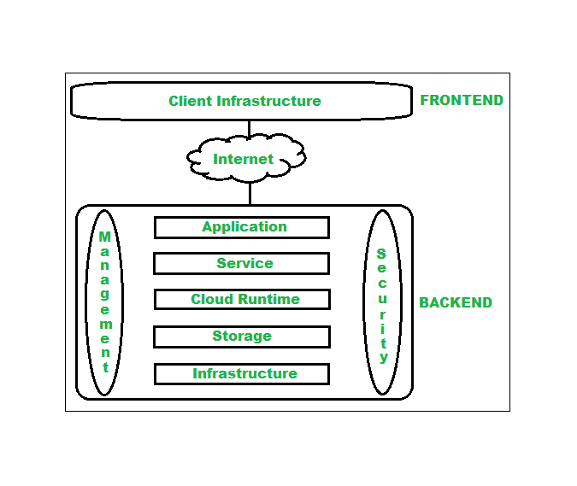

Architecture of Cloud Computing

Architecture of cloud computing is the combination of both SOA (Service Oriented Architecture) and EDA (Event Driven Architecture). Client infrastructure, application, service, runtime cloud, storage, infrastructure, management and security all these are the components of cloud computing architecture.

**1. Frontend :**  
Frontend of the cloud architecture refers to the client side of cloud computing system. Means it contains all the user interfaces and applications which are used by the client to access the cloud computing services/resources. For example, use of a web browser to access the cloud platform.

* **Client Infrastructure –** Client Infrastructure is a part of the frontend component. It contains the applications and user interfaces which are required to access the cloud platform.
* In other words, it provides a GUI( Graphical User Interface ) to interact with the cloud.

**2. Backend :**  
Backend refers to the cloud itself which is used by the service provider. It contains the resources as well as manages the resources and provides security mechanisms. Along with this, it includes huge storage, virtual applications, virtual machines, traffic control mechanisms, deployment models, etc.

1. **Application –**  
   Application in backend refers to a software or platform to which client accesses. Means it provides the service in backend as per the client requirement.
2. **Service –**  
   Service in backend refers to the major three types of cloud based services like SaaS, PaaS and IaaS. Also manages which type of service the user accesses.
3. **Runtime Cloud-**  
   Runtime cloud in backend provides the execution and Runtime platform/environment to the Virtual machine.
4. **Storage –**  
   Storage in backend provides flexible and scalable storage service and management of stored data.
5. **Infrastructure –**  
   Cloud Infrastructure in backend refers to the hardware and software components of cloud like it includes servers, storage, network devices, virtualization software etc.
6. **Management –**  
   Management in backend refers to management of backend components like application, service, runtime cloud, storage, infrastructure, and other security mechanisms etc.
7. **Security –**  
   Security in backend refers to implementation of different security mechanisms in the backend for secure cloud resources, systems, files, and infrastructure to end-users.
8. **Internet –**  
   Internet connection acts as the medium or a bridge between frontend and backend and establishes the interaction and communication between frontend and backend.

**Benefits of Cloud Computing Architecture :**

* Makes overall cloud computing system simpler.
* Improves data processing requirements.
* Helps in providing high security.
* Makes it more modularized.
* Results in better disaster recovery.
* Gives good user accessibility.
* Reduces IT operating costs.

# Cloud Computing Challenges

Cloud computing, an emergent technology, has placed many challenges in different aspects of data and information handling. Some of these are shown in the following diagram:

1. **Security and Privacy**

Security and Privacy of information is the biggest challenge to cloud computing. Security and privacy issues can be overcome by employing encryption, security hardware and security applications.

1. **Portability**

This is another challenge to cloud computing that applications should easily be migrated from one cloud provider to another. There must not be vendor lock-in. However, it is not yet made possible because each of the cloud provider uses different standard languages for their platforms.

1. **Interoperability**

It means the application on one platform should be able to incorporate services from the other platforms. It is made possible via web services, but developing such web services is very complex.

1. **Computing Performance**

Data intensive applications on cloud requires high network bandwidth, which results in high cost. Low bandwidth does not meet the desired computing performance of cloud application.

1. **Reliability and Availability**

It is necessary for cloud systems to be reliable and robust because most of the businesses are now becoming dependent on services provided by third-party.